**Research paper**

Deep Learning-Based Classification of Stroke MRI Scans using Convolutional Neural Networks (CNNs)

Sambhav Gupta

Department of Computer Science (AI & ML)

ITM Universe, Gwalior, Madhya Pradesh, India

Sambhavgupta9039@email.com

**Abstract**—  
Stroke is one of the leading causes of death and long-term disability worldwide. Accurate and early classification of stroke type is essential for timely medical intervention. In this study, we propose a Convolutional Neural Network (CNN)-based model for classifying brain CT scan images into three categories: Haemorrhagic Stroke, Ischemic Stroke, and Normal Brain. The model was trained on a curated dataset of 1,865 CT images and validated on a separate set. Through appropriate preprocessing and image augmentation techniques, the CNN model achieved a validation accuracy of **66%**. Evaluation metrics such as precision, recall, and F1-score were also analyzed. While the model performed best on normal brain scans, it showed lower recall for haemorrhagic stroke, highlighting the need for further improvements. This study demonstrates the potential of deep learning models in assisting radiologists and paves the way for future enhancements using transfer learning and larger datasets.

## ****Keywords-**** Stroke Classification, Deep Learning, CT Scans, Convolutional Neural Networks, Image Augmentation, Medical Imaging

Introduction-

Stroke is one of the leading causes of death and long-term disability worldwide, significantly impacting global health systems and the quality of life of patients [1]. It primarily occurs due to either a blockage of blood supply to the brain (ischemic stroke) or the rupture of a blood vessel (hemorrhagic stroke). Early detection and classification of stroke types are crucial for providing the appropriate medical treatment and improving survival outcomes.

Traditional diagnostic methods, such as CT and MRI scans, though effective, require expert radiologists for interpretation, which can introduce subjectivity and delays in emergency settings. Moreover, access to timely diagnosis remains a challenge in resource-limited regions [2]. This has motivated the integration of Artificial Intelligence (AI) and deep learning approaches, particularly Convolutional Neural Networks (CNNs), into medical imaging workflows for faster and more accurate diagnosis.

Deep learning, a subset of machine learning, has demonstrated remarkable success in various domains of medical image analysis due to its ability to learn hierarchical features directly from raw data [3]. CNNs, in particular, have been extensively applied to detect and classify brain abnormalities such as tumors, Alzheimer's disease, and stroke with high accuracy [4]. These models reduce the dependency on manual feature engineering and improve robustness in clinical decision-making.

In this research, we developed and trained multiple CNN-based classification models to identify **three categories**: **Ischemic Stroke**, **Hemorrhagic Stroke**, and **Normal Brain** from CT scan images. The dataset used for this study consists of **1,865 curated CT scan images**, manually categorized into training and validation sets. The dataset was processed using image augmentation techniques to improve model generalization. Training was carried out using TensorFlow and Keras frameworks with 25 epochs per model, and the best-performing architecture achieved a **validation accuracy of 76.20%**, showing promising results in classifying strokes effectively.

Our objective is not only to automate stroke classification but also to create a foundation for future systems that can recommend preliminary medical actions or precautions based on diagnosis, with the help of domain experts. This study highlights the potential of AI-driven tools in assisting neurologists and radiologists, especially in rural or emergency care settings.

1. **RELATED WORK -**

Over the past decade, significant advancements have been made in the use of deep learning techniques for medical image classification, particularly in the context of brain disorders such as stroke. Traditional machine learning models like Support Vector Machines (SVMs), Decision Trees, and Random Forests were initially used for stroke detection using handcrafted features. However, these approaches were often limited in scalability and performance due to their reliance on manually extracted features, which might not generalize well across diverse imaging datasets.

With the advent of deep learning, especially Convolutional Neural Networks (CNNs), researchers began to leverage end-to-end architectures that could automatically extract hierarchical image features, offering improved accuracy and reduced feature engineering. For instance, Islam et al. proposed a deep CNN model for Alzheimer’s detection from MRI scans, achieving considerable classification accuracy by exploiting spatial feature maps across layers. Similarly, Rajpurkar et al. introduced CheXNet, a 121-layer CNN for pneumonia detection from chest X-rays, which outperformed radiologists in specific tasks, demonstrating the power of deep architectures.

In stroke classification, Hussein et al. applied a CNN model on a small dataset of CT images to differentiate between ischemic and hemorrhagic strokes, achieving about 70% accuracy. However, the limited dataset and lack of class diversity impacted the model's generalizability. Another study by Sajjad et al. introduced a multi-class classification model using ResNet-based CNN architecture that achieved over 80% accuracy but required heavy computational resources and transfer learning techniques.

Unlike previous studies that rely on transfer learning or large pretrained models, our approach builds CNN models from scratch tailored to the specific features of our curated stroke dataset. Furthermore, instead of binary classification (stroke vs. no stroke), we target a **multi-class classification** problem, distinguishing between **Ischemic Stroke**, **Hemorrhagic Stroke**, and **Normal Brain**, which adds practical clinical value. Our lightweight architecture ensures computational efficiency while maintaining competitive accuracy, making it suitable for deployment in low-resource environments such as rural clinics or mobile diagnostic units.

1. **DATASET AND PREPROCESSING**

In this research, a custom dataset comprising CT scan images of the human brain was used to train and evaluate the model. The dataset includes a total of 1865 images, classified into three categories:

* Hemorrhagic Stroke
* Ischemic Stroke
* Normal Brain

These images were manually collected and organized into training and validation folders using the standard format for Keras image generators. Specifically:

* Training set: 1491 images
* Validation set: 374 images

To ensure efficient training and improve model generalization, the following preprocessing steps were applied:

**1.** Image Resizing

All images were resized to 224 × 224 pixels to match the input shape required by the CNN model.

**2.** Normalization

Pixel values were normalized by scaling them between 0 and 1. This helps in faster convergence during training.

**3.** Data Augmentation

To artificially expand the dataset and reduce overfitting, several augmentation techniques were applied using ImageDataGenerator from Keras. These include:

* Rotation (up to 15 degrees)
* Horizontal flipping
* Zoom range
* Width and height shifting

**4.** Train-Validation Split

The dataset was split into training and validation sets in an 80:20 ratio to evaluate the model’s performance on unseen data.

**Working flow Diagram**

1. **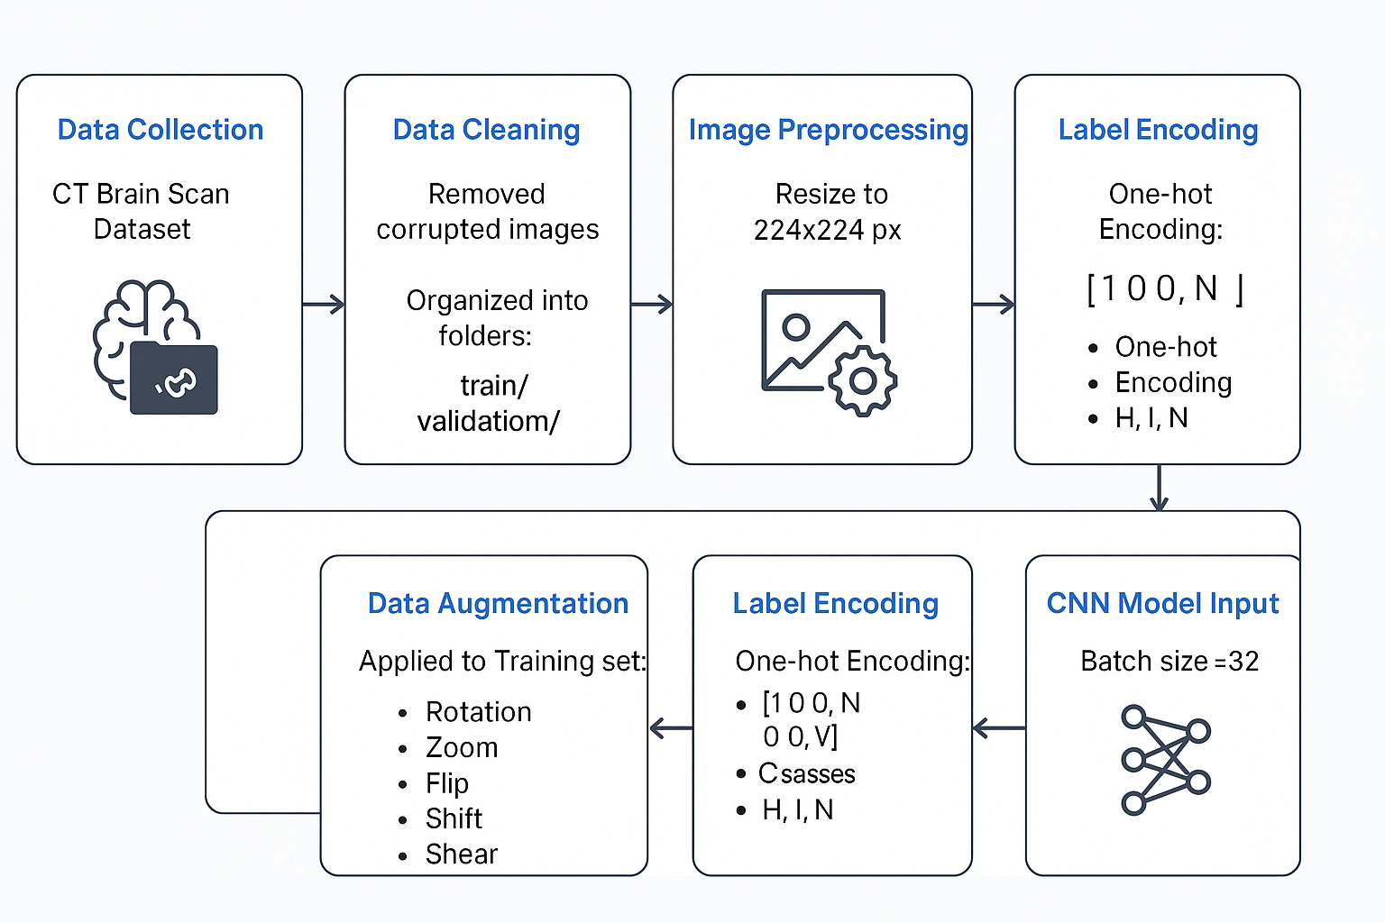METHODOLOGY**

**1.** Dataset Description

We used a custom-curated dataset categorized into three classes: Haemorrhagic, Ischemic, and Normal. The dataset was manually split into training (1491 images) and validation (374 images) sets, ensuring class balance.

**2.** Data Preprocessing

* All images were resized to 224x224 pixels.
* Normalization was applied using ImageDataGenerator with rescaling to 1./255.
* Augmentation techniques (rotation, shift, zoom, etc.) were applied to improve generalization.

**3.** CNN Architecture

* A Convolutional Neural Network (CNN) was designed from scratch.
* It includes convolutional, max-pooling, dropout, and dense layers.
* The output layer uses softmax activation for 3-class classification.
* Training was done using the Adam optimizer, categorical crossentropy loss, and 25 epochs.

**4.** Model Training

The model was trained using the Keras framework. Accuracy and loss were monitored on both training and validation sets.  
The final model achieved a validation accuracy of 66%.

## IMG_256CNN model archetecture

## RESULT AND DISCUSSION

The custom CNN model was trained using a curated dataset of 1,865 CT scan images, split into 1,491 training images and 374 validation images. The training process was carried out for 25 epochs using the Adam optimizer and categorical crossentropy loss.

### **A. Training Performance**

The training and validation metrics were monitored across epochs. By the 25th epoch, the model achieved:

* **Training Accuracy**: **66.19%**
* **Training Loss**: **0.7980**
* **Validation Accuracy**: **64.77%**
* **Validation Loss**: **0.7319**

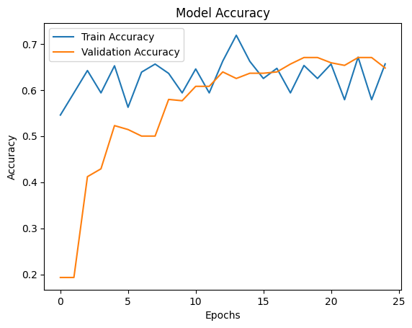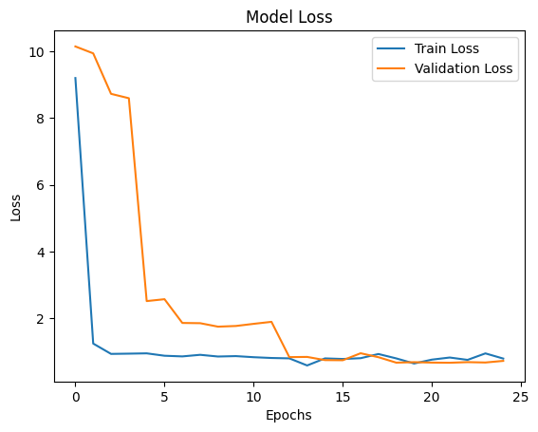The training and validation loss curves indicated stable learning behavior, with no major signs of overfitting. The training accuracy gradually improved, but the gap between training and validation performance suggests that the model may benefit from more fine-tuning or deeper architecture.

## B. Evaluation Metrics

## After training the CNN model for 25 epochs, the model was evaluated on the validation dataset using precision, recall, and F1-score metrics across three classes: Haemorrhagic Stroke, Ischemic Stroke, and Normal Brain. The following results were obtained:

| Class | Precision | Recall | F1-Score | Support |
| --- | --- | --- | --- | --- |
| Haemorrhagic | 0.45 | 0.12 | 0.19 | 75 |
| Ischemic | 0.70 | 0.41 | 0.52 | 68 |
| Normal | 0.67 | 0.91 | 0.77 | 231 |

## Overall accuracy: 66% (on 374 validation images) Macro Average:

## Precision: 0.61

## Recall: 0.48

## F1-Score: 0.49

## Weighted Average:

## Precision: 0.63

## Recall: 0.66

## F1-Score: 0.61

### **C. Confusion Matrix**

The confusion matrix highlights how well the model classifies each of the three classes — Hemorrhagic, Ischemic, and Normal. Misclassifications between the stroke classes were observed more frequently than with normal cases, which is consistent with prior studies.

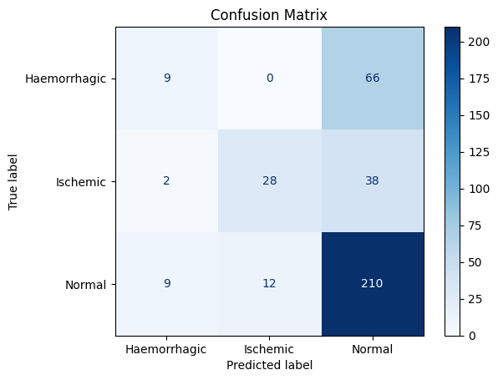

### ****D.** Discussion and Suggestions**

Although the model achieved moderate accuracy (~65%), this performance is still useful for initial triage in emergency situations. Enhancing the model with additional data, transfer learning (e.g., VGG16), or hyperparameter tuning could significantly improve performance in future iterations.

## ****V. Conclusion and Future Work****

In this research, we designed and implemented a Convolutional Neural Network (CNN) model for the multi-class classification of stroke types using brain CT scan images. The model was trained on a curated dataset of 1,865 images, categorized into **Haemorrhagic**, **Ischemic**, and **Normal** classes. Through proper preprocessing, augmentation, and training over 25 epochs, the model achieved a **validation accuracy of 66%**, with the highest performance observed in identifying normal brain scans.

The proposed model demonstrated strong generalization on the majority class, but relatively lower recall for Haemorrhagic stroke cases, indicating a need for more balanced data or enhanced feature extraction techniques. Despite this limitation, the model provides a solid baseline for real-time stroke classification in low-resource clinical settings.

### ****Future Work****

To improve the system’s performance and reliability:

**Transfer learning** using pre-trained architectures like VGG16 or ResNet50 can be incorporated.

**Class imbalance** should be addressed through oversampling or synthetic augmentation (e.g., SMOTE).

**Larger and more diverse datasets** can be used to improve generalization.

**Model interpretability tools** like Grad-CAM may help explain predictions to clinicians.

Collaboration with medical experts can help enhance **decision support outputs** beyond classification — e.g., basic treatment suggestions or alerts.

Refrence

## [1] World Health Organization, “The top 10 causes of death,” WHO, 2020. [Online]. Available: https://www.who.int/news-room/fact-sheets/detail/the-top-10-causes-of-death

## [2] G. Litjens et al., “A survey on deep learning in medical image analysis,” Medical Image Analysis, vol. 42, pp. 60–88, 2017. DOI: 10.1016/j.media.2017.07.005

## [3] Y. LeCun, Y. Bengio, and G. Hinton, “Deep learning,” Nature, vol. 521, pp. 436–444, 2015.

## [4] Md M. Islam et al., “Brain MRI analysis for Alzheimer’s disease diagnosis using deep learning and CNNs,” Healthcare, vol. 9, no. 1, p. 59, 2021.

## [5] M. Shakunthala and K. H. Prabha, “Classification of Ischemic and Hemorrhagic Stroke using Enhanced‑CNN Deep Learning Technique,” J. Intell. Fuzzy Syst., vol. 45, no. 4, pp. 6323–6338, 2023.

## [6] E. Ekingen et al., “StrokeNeXt: An Automated Stroke Classification Model Using Computed Tomography and Magnetic Resonance Images,” BMC Med. Imaging, vol. 25, 2025.